Tucson Territorial Estates Lots 637, 638, 639, 640
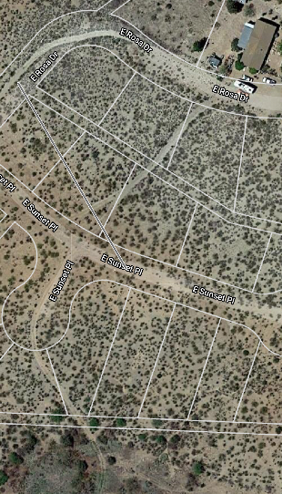

Lot 637

Lot 638

Lot 639

Lot 640


